Youth Entrepeneurs Now
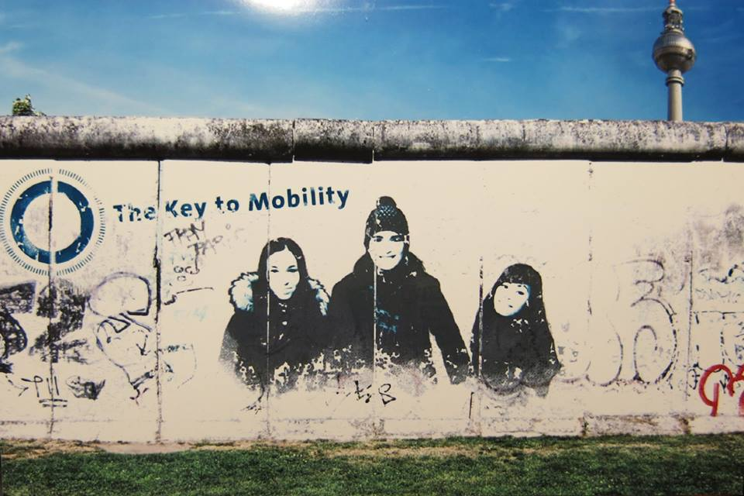

Mobility Project in the field
of Youth
8-17 September 2016
Berlin, Germany

Dear participants,
We are glad to welcome you to the youth exchange “Young Entrepreneurs Now’’ and are looking forward to meet you in Berlin very soon. Please, read all the provided information carefully and don’t hesitate to contact us with anything related to your participation in the project.
About the organizer
The organizer of project is Zentralrat der Serben in Deutschland e.V. organization from Germany. The main aim of our organization is representing the interests of Serbs who are living in Germany; Active participation in the constructive process of integration into German society without losing national identity and as a contribution to the construction of a multi-cultural society.; The maintenance, care and support of Serbian culture, traditions, language and history; Encouragement and strengthening of cooperation between regional organizations and the federal level and their connection with other associations, organizations and authorities in Germany; Support in the realization of various projects with Serbian and Serbian associations in Germany; Coordination of activities of Serbian Associations in federal and a regional level and supporting and promoting the economic relations between Germany, European Union and the Republic of Serbia.
See you soon
Zentralrat der Serben in Deutschland e.V.

About the project
The aim of this project is to come to terms with issues of employability and entrepreneurship by providing participants with knowledge and skills necessary for self-management, entrepreneurial competitiveness and the promotion of social inclusion.
Objectives
- Achieving a common understanding of the terms “employability” in general and their realization in different national contexts
- Promoting a sense of initiative, empowerment and entrepreneurship as a proper means of tackling youth unemployment
- Creating a network of youngsters interested in entrepreneurship and social change willing to further engage in these topics and ideally realizing future joint-projects
- Getting to know the possibilities of EU programs and funds available to support the reduction of youth unemployment
- Promoting (inter)cultural dialogue and exchange among the participants and their sending organizations
Activities:
Workshops on topics: unemployment, situations in partner countries about unemployment, sense of initiative and entrepreneurship, presentation of good practice in partner countries and in Germany and business plan.
Erasmus+ and Youthpass where participants will get informed about opportunities under this programme and how to evaluate knowledge gained on the youth exchange
Presentation of organizations where participants can learn more about the parnter orgnaization, its objectives, activities, previous experience and best practices in topic on entrepreneurship.
Intercultural night where participants will increase awareness and understanding of the cultural and ethnic diversity, create an atmosphere of neighbourly celebration, educate about cultural differences and similarity of countries participate.
The methodology is based on fundamental principles of non-formal education. Technique as work in small groups, discussions, presentation of good practices and others will allow participants to participate fully in the learning process, learning from experience and facilitating interaction and full participation in the group.
Partner organizations
- Ecological Association for the protection and improvement
of the environment "EKO-MLADENOVAC"
- Be - Education, Equality, Sustainability
(Sei - Bildung, Gleichheit, Nachhaltigkeit)
- Asociacija "Apkabink Europa"
- Change it!
- Associació Cultural Tabalà
- Pan - European Alliance Skopje

Target group:
Participants will be 42 participants form Austria, Czech Pepublic, Germany, Lithuania, Spain, Serbia and Macedonia. Each partner will select 6 participants: 5 participants and 1 team leader. Participants should be:
- motivated and interested in exploring entrepreneurship and unemployment;
- in a position to multiply the experience gained during the course in their local communities;
- ready ready to develop and (ideally) implement realistic follow-up activities;
- Be available for the full duration of the course;
- Be able to work in English;
- Between 18 – 30 years of age (In exceptional cases the leader can be older than 30 years upon approval of the organizers!)
- Dissemination of results is very important and it is expected that each partner promote project and share results of project in local community.
Financial conditions

The youth exchange is implemented by support of the European Commission programme ERASMUS+ and the German National Agency. Travel Expenses (according to Erasmus+ guidelines), accommodation, food and planned activities will be covered by the project budget.
Important notice on food:
Please, keep in mind, that the provided food may differ from the food you are used to have in your country, and, even in case of providing food for special groups, e.g. (if you are heavily meat eater or vegetarian) it may not fully meet your expectations. We strongly recommend participants to inform the organizers IN ADVANCE about any special needs.
Travel costs
Reimbursement will be done in EUR. All tickets' costs purchased in a local currency will be converted and calculated according to the exchange rate of the month given by the European Commission. Find the details here:
http://ec.europa.eu/budget/contracts_grants/info_contracts/inforeuro/inforeuro_en.cfm
The travel reimbursement will be done by a bank transfer after the project upon receiving all the original travel documents (boarding passes, train, bus tickets) to one representative of the group or a partner organization.
Every participant should submit the following documents for the reimbursement:
- Tickets (there must be price and name of the person stated on it).
- Boarding passes (in case of loss – please get a confirmation from the airlines, that the flight was taken)
- Invoices – yes, even if you have a ticket, our accounting still needs an INVOICE.
- Online Check-in should be made before your leave Yerevan to make sure you give as
- Boarding Passes from the way back as well.

IMPORTANT: Be aware that you can wait 6 months for reimbursement of travel costs. We have to wait second part of money that will be given after National Agency approves our final report.
There is NO participation fee for this youth exchange.
Country | Money in €
Serbia | 170
Macedonia | 170
Lithuania | 170
Germany | 0
Spain | 170
Czech Republic | 80
Austria | 170

Weather
The weather in Berlin in September is relatively warm and sunny. You can check the weather before to arrive in Germany
http://www.accuweather.com/en/de/berlin/10178/month/178087?monyr=9/01/2016
Visa
In case if you need visa, you can let us to send you invitation letter. However, visa costs will not be reimbursed. Please, don't forget to bring your passport or ID with you.
Insurance
Remember health insurance is your responsibility, so make sure you have medical insurance. Also you are required to have travel insurance. Please note that each participant is required to have travel insurance and health insurance and it is not reimbursable as it is your choice with which company and plan suits you. Travel Insurance (For participants from EU countries the European Health Insurance
Card (EHIC) is advised!)
Currency
Germany currency is Euro; if you need to change money you can do it in the airport or in any bank.
Emergency
112 emergency is traditionally considered as a "fire emergency" and "emergency medical assistance" number and 110 is known as the "police emergency" number in Germany. It is not possible to call 112 from a mobile phone without a SIM card. In addition to German, the calls can be answered in English and the other EU languages with the help of interpreters. The 112 operator can detect the location of the caller immediately. Copied form this site:
https://ec.europa.eu/digital-single-market/en/112-germany
Medication
If you take any medication please remember to bring it with you, we have pharmacies here but if you need prescription medication you cannot buy them over the counter without a prescription. Also please inform us of any medical conditions we need to be aware of in the registration application. If participants have any allergies especially to food this needs to be expressed in the application form above, because changes to the menu will not be possible once the project starts.
Smoking and alcohol
We do not encourage drinking and smoking , but if you want to do it ,do it responable. It is forbidden to smoke or drink inside of your rooms and activities places.
Drugs
It is completely forbidden to use drugs including “light drugs”
What to bring
- Travel Insurance (For participants from EU countries the European Health Insurance
- Card (EHIC) is advised!)
- Printed materials to represent your organization and/or projects
- PASSPORT and a copy to leave with the organizers
- Information about the level of youth unemployment and entrepreneurship in your home country
- Some traditional food/drinks to share during the Youth Exchange
- Good Mood
Venue
Project will be held in Berlin
We will send you soon more information about hotel, working place and how to come to hotel form airoprt or bus station.

PLEASE NOTE: WE WILL MAKE ROOM SCHEDULES IN ADVANCE. REARRANGEMENTS ARE NOT POSSIBLE UPON ARRIVAL.
For more additional information and further questions you can contact us on:
SEE YOU SOON!

