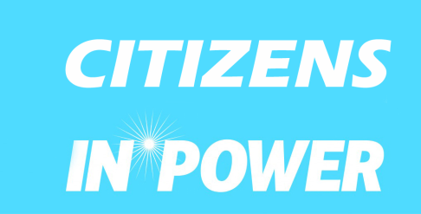

**Participants Info Pack**

**A Network for your ‘NET-worth’!**

Training course

**15 September - 20 September 2015**

**Nicosia, Cyprus**

**Deadline to apply (not to book tickets) 28/05/2015**

The “A.N.NET” training will be hosted in Nicosia, Cyprus by Citizens In Power from 15/09/2015 until 20/09/2015 in cooperation with partner organizations from Italy, Lithuania, Romania, Estonia, Spain, Czech Republic, Latvia, Bulgaria and Slovakia.

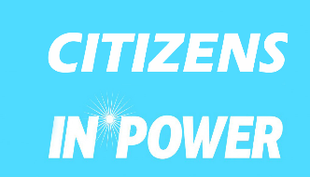

**Organizer**

**Partners**

* **1.CITIZENS IN POWER – (Cyprus)**
* **2.Asociatia Dominou (Romania)**
* **3.Associazione di Promozione Sociale Futuro Digitale (Italy)**
* **4. Jaunimo verslumo ir saviraiskos skatinimo labdaros ir paramos fondas (Lithuania)**
* **5.Baltic Regional fund (Latvia)**
* **6. Change it! (Czech Republic)**
* **7.SEIKLEJATE VENNASKOND (Estonia)**
* **8. A.D.E.L. - Association for Development, Education and Labour. (Slovakia)**
* **9.ASOCIACION BUILDING BRIDGES (Spain)**
* **10.The Change is in You (Bulgaria)**

**About the organizer**

Citizens in Power is an independent non profit / nongovernmental organization) that addresses the needs and demands of young people through their involvement in civic life.

CIP’s aims at the development of democratic dialogue and entrepreneurship in Cyprus and abroad.

What we do:

-Work for increasing the employability of young people through entrepreneurship education and practical experience.

-Organize structured dialogues with decision makers

-Support and train members of our local and international networks in numerous ways such as exchange of information, good practices, experiences and ideas.

-Participate in the activities Cyprus Youth Council as members

www.citizensinpower.org

**The Training Course**

NGO’s youth-workers who are currently working on entrepreneurship, must be continually updated, in the dynamic environment of entrepreneurial education. Taking into consideration all the above strategic ideas, this networking training aims at bringing the organizations which specialize on entrepreneurship together, by intending to work on concrete objectives. More specifically, the targets of the training contain:

-The sharing of non-formal educational methods that motivate, and therefore engage young people with entrepreneurial activities.

-The sharing of special techniques that empower young people deriving from the alleged ‘marginalized areas’ such as migrants and people with disabilities, to take entrepreneurial action.

-The development of collaborations and partnerships, capable to submit applications for KA1 and KA2 action.

-The learning of ways, primarily by giving the right opportunities through both the appropriately-designed activities and the whole training process, to widen the participants’ network.

The “A.N.NET” training will be hosted in Nicosia, Cyprus by Citizens In Power from 15/09/2015 until 20/09/2015 in cooperation with partner organizations from Italy, Lithuania, Romania, Estonia, Spain, Czech Republic, Latvia, Bulgaria and Slovakia.

* **Working Methods and Language**

**WORKING METHODS**

* The training will be based on non-formal education methods, encouraging active participation of young people involved.
* Ice-breakers, energizers, group-building games
* Simulations
* Role plays
* Intercultural and experiential learning
* Brainstorming and discussions both in working groups and in plenary
* Inputs from experts

**WORKING LANGUAGE**

English

* **Eligible Participants**
* Youth workers
* Young people interested at the objectives of this project and they are willing to share what they will learn in their respective organizations
* **Travel and Finances**

Travel expenses are a heavy burden on the budget of this project. Participants are therefore required to arrange their journeys in the most economical manner possible. In order to find the most economic tickets we advise you to visit [www.skyscanner.net](http://www.skyscanner.net) .

-Larnaca International Airport - has the biggest number of airlines and connections. Closest to the venue, cheap flights by blue air, wizzair, Aegean airlines and others

- Paphos Airport (second airport of Cyprus). Cheap flights by Ryanair, easy jet and others

Irrespective of the means of the transport used, participants will be reimbursed on the basis of the **least expensive route** between their place of residence and the town in which the course is held.

**Please don’t book any tickets without our confirmation.**

FUNDING CONDITIONS:

ERAMSUS+ Programme, Key Action 1

100% of accommodation and activity costs are covered by the programme

The international travel costs are covered according to the rules of ERAMUS+ YiA KA1

(distance band calculator, 100-499 km = 180 euro, 500-1999 km = 275 euro, 2000-2999 km = 360 euro, 3000-3999 km = 530 euro, 4000-7999 km = 820 euro)

**Participants’ travel costs to and from Cyprus per country (including the cost of plane, bus:**

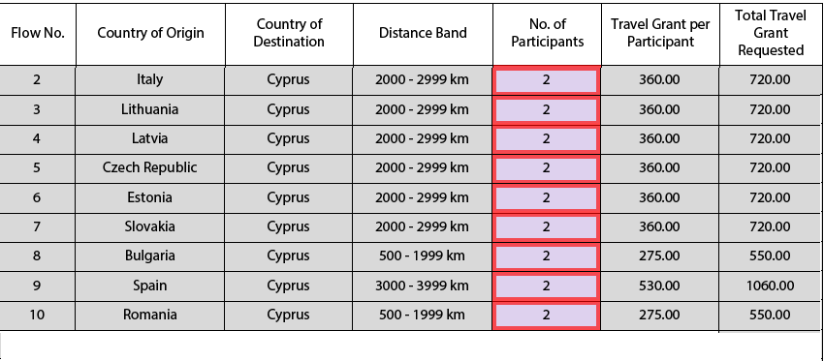

**Please note: eligible airports for landing are the international airport of Larnaca and Paphos**

**Visa**

In case you need a visa to come to Cyprus,

<http://www.mfa.gov.cy/mfa/mfa2006.nsf/0/BCD9E71A8FBBA8DCC225720B001D9AFE?OpenDocument>

or

<http://www.cyprusvisa.eu>

After you receive our confirmation for booking your tickets and you’re not sure how to book your flight, feel free to ask us, we will be happy to help you. ☺

**Documents needed to complete your reimbursement:**

In order for the Citizens in Power to precede to your travel reimbursement you must present when requested the following documents:

* Invoice or copy of credit card slip of the travel payments.
* Boarding pass (please resist throwing them away in the nearest bin after you leave the plane – you will NOT be refunded without them).
* Travel reimbursement form (which you should collect in the reception on your arrival).
* Relevant tickets or a copy (plane, bus, etc).

**For electronic tickets:**

* Boarding pass (please resist throwing them away in the nearest bin after you leave the plane – you will NOT be refunded without them).
* Invoice or copy of credit card slip/ e-banking printout.
* Travel reimbursement form (will be provided on the arrival).
* Printed travel itinerary.
* Travel refund to the participants will be paid by bank transfer ( within 45 days) to organizational account/personal account for the whole group after all travel documents will be received by the Citizens in Power.
* **NOTE that NO electronic tickets will be reimbursed if the original invoice is not be provided.** Thereimbursement will be done via bank transfer within 1 month, after the receipt of all travel documents including boarding passes.

**Participation fee**

**The participation fee is 35 euro per participant**. Participation fee is not reimbursed and will be deducted from the reimbursement or will be paid in cash by participants during the training.

The participation fee is used to cover various operational expenses for additional extraordinary activities. Such us bus service (for a networking trip to Agia Napa), dining at a traditional restaurant.

* **Accommodation**

Name: Youth Hostel

10 min walk from the city center

The converted old building which opened up to travelers and tourists in May 2012, straddles three quaint streets just by the Chrysaliniotissa church in the old city and has been beautifully renovated. The vision was that of preserving the great traditional urban architecture of the original building, coupled by contemporary changes to modernize the interiors with the 21st century design.

A look inside the premises reveals a beautifully lit and spacious downstairs lobby which gives way to a conference room and computer room. The interior is filled with stone details coupled with the characteristic interior archways, dark wooden floors and the renovated grand old staircase that leads up to the bedrooms and kitchen area. There are five en suite rooms in total that can accommodate up to 20 people. Perhaps the most impressive part of the building is the modern kitchen area boasting a lovely balcony overlooking the church and old town, topped off by a clerestory-style row of upper ground floor lancet windows, usually associated with ecclesiastical buildings. Newly fitted stained glass panels replacing the older ones give the building almost a gothic feel.

Kitchen Bedroom (4 persons per room)



Dining area

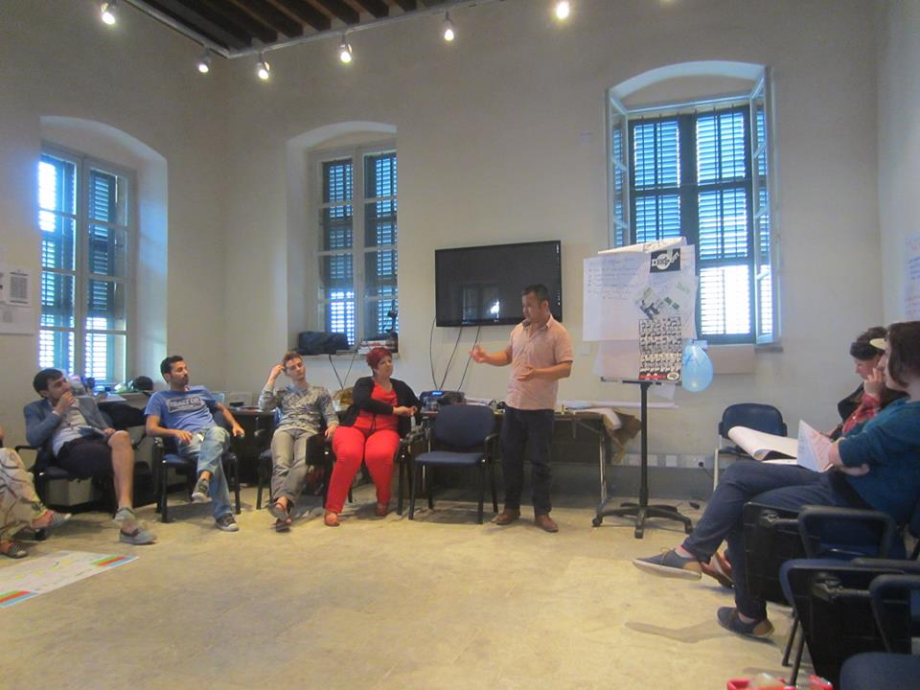

Conference room/working area

Note: participants will be allocated in bedrooms with 4 persons each.

Contact details

Tel: 22459691

Address:30-32 Chrusaliniotissis str, 1017 Nicosia

**Food**

**The food will be prepared by private catering company**

[**www.kapatsos.com**](http://www.kapatsos.com)

**Participants might be asked to choose their food for lunch or dinner ( 2 times only for the whole duration of the training) by themselves so they can eat at a restaurant of their choice in the city center. We will announce during the training the reimbursement limit for eating at the city center.**

* **How to get to Nicosia from Paphos or Larnaca**

Please check the detailed schedule at <http://www.kapnosairportshuttle.com/> and then book your tickets. In case you miss the bus, you will not be charged. The payment is made in Cyprus at Kapnos station. The booking guarantees you a sit in the bus.

From Larnaka and Paphos International Airport you should take KAPNOS Airport Shuttle to Nicosia. Before exiting the airport, search for the Airport Shuttle KAPNOS (meaning – in Greek- and moving like SMOKE!) and buy your ticket to Nicosia, and then search for your bus outside the airport. The ticket will cost €8 Euros from Larnaca and 15 Euros from Paphos (oneway ticket, the amount for the tickets is already included in the given budget, keep The receipt!), and the 40-minute-long trip ( 80-90 min from Paphos) will bring you to the bus parking area, where Stelios Demosthenous or one of our voluteers, will be waiting for you.

Kapnos telephone number: +357 24008718.

About your travel details (from the airport to bus station, arrival to Nicosia, all the schedules), please contact Angelos Parmatzias, by email at [angelos_parmatzias@msn.com](mailto:angelos_parmatzias@msn.com) or by phone at +357 96619661 (mobile phone).

Please note that taxi service is not reimbursed in any case!

* **Some Practicalities**

The price of products and services in Cyprus varies depending on the season and the location.

Below is an indicative list in Euro:

* A single bus ticket costs around €1
* Water (0,5l) from €0.50 in a local kiosk
* Shower gel from €2.50
* Small juice pack (0,20L) from €0.50
* Toothpaste from €2.50
* Phone card with €5 of credit from €5.00
* Chocolate from €0, 70
* Fast food from €3.00-7.00
* A glass of beer costs between €3.50 and €5.00
* A ticket to the cinema costs around €7.00 for adults and €5.00 for children
* Dinner at a local tavern (meze, including beer or cold drink) costs around €20.00
* **COMMUNICATIONS: MAKING PHONE CALLS**

In order to make a phone call to Cyprus from abroad, dial 00357 and then the eight-digit phone number. If you wish to make a phone call abroad while in Cyprus, dial 00, followed by the country code and the telephone number. International calls can be made from public telephones available at various central locations in all cities and villages, as well as at international airports, harbours and elsewhere. There are three types of public telephones – coin phones, outdoor card phones and indoor card phones. Public payphones can be used for both national and international calls. Dialing instructions as well as rates are displayed in all payphones. Calling within Cyprus simply requires dialing the eight-digit telephone number.

* **Money and Currency**

The currency of the Republic of Cyprus is the Euro. There are seven denominations in Euro banknotes: 5, 10, 20, 50, 100, 200 and 500 euro. They all have different colour and size, the higher the denomination, the bigger the size. One euro is divided into 100 cent. There are eight euro coins: 1, 2, 5, 10, 20 and 50 cent, €1 and €2. The designs on one side of the coins are common to all the countries of the euro area, while the other side reflects national identities. All euro coins can be used in all euro area countries, irrespective of their national side.

* **Weather Conditions**

Cyprus enjoys an intense Mediterranean climate of hot dry summers starting in mid-May and lasting until mid-September and rainy, quite mild winters from November to mid-March. Spring and autumn are effectively short intervals in between, characterized by smooth weather. With almost year-round clear skies and sunshine, daylight length ranges from 9.8 hours in December to 14.5 hours in June.

[For more information click HERE](http://www.holiday-weather.com/paphos/averages/).

And for a very accurate ten-day weather forecast by CNN (that will also help you organize your clothing and suitcase accordingly) [click HERE](http://weather.edition.cnn.com/weather/intl/forecast.jsp?locCode=CYXX0005&zipCode=325873587767).

* **What to bring**
* Spring- summer Clothes.
* Medicines if you need.
* Musical instruments and other stuff – we will have free time to enjoy together.
* Alarm clock.
* Athletic shoes.
* Motivation and good mood.
* **Some facts about Cyprus**

Floating on the waters of the Mediterranean, but pointing longingly towards the shores of Syria, Turkey and Lebanon, Cyprus is an odd mixture. It is a kaleidoscopic blend: its cultural influences are dominated by Western Europe, but its geographic proximity to Asia and Africa gives it more than just a hint of the East. Long coveted by mainland Greece and Turkey, this small island has its own definite and beguiling character.

Cyprus is the island for all seasons, the island of good weather, good mood and loads of sunshine! The people of Cyprus are warm – hearted, hospitable and kind, people who love to go out and who appreciate good company and good food. In fact, most of the social outings and relationships revolve around food! And that’s food that is coming in a lot of variety and large quantities for massive stomachs!



**While in Cyprus it’s a must that you try:**

* Cypriot meze (appetizers akin to Spanish tapas) are an art form, and some restaurant serves nothing but just that! Meze are available in a meat variety or fish variety but quite often come as a mixed batch, which is rather pleasing.
* Sheftalia which is a kind of sausage without skin. The filling of sheftalia is made of ground pork or lamb shoulder and leg. It is mixed with fine chopped onions and parsley and seasoned with salt and pepper. Instead of sausage casing it uses caulk fat, the membrane that covers the stomach of a lamb or pig, to wrap the ingredients. In words it may not sound so good but in the mouth it is simply yummy yummy!!!
* Halloumi is a uniquely Cypriot cheese, made from a mix of cow's and sheep's milk. Hard and salty when raw, it mellows and softens when cooked and is hence often served grilled.
* Taramosalata is traditionally made out of taramas, the salted roe of the cod or carp. The roe is either mixed with bread crumbs or mashed potatoes. Parsley, onion, lemon juice, olive oil and vinegar are added and it is seasoned with salt and pepper.

And of course this is just a short list. There are plenty more tastes and dishes to try! Another important thing about Cyprus is the social life of Cypriots who normally spend their free time (mornings, afternoons, evenings, we simply don’t mind) going for coffee in several coffee shops around the city, that stay open until around one o’clock at night! Coffee is quite popular even at 10 or 11 pm and what is also very popular is the special “frappe”, which seems to be something like a Greek coffee invention. Later, during the evenings people hit the clubs at around 12:30 with the party lasting until the early hours of the morning, when again they try to get rid of the hangover with more food at local fast food restaurants.

[For more information visit click HERE](http://www.virtualtourist.com/travel/Europe/Cyprus/Nicosia_District/Nicosia-394344/Things_To_Do-Nicosia-TG-C-1.html).

* **Discover Nicosia**

Lefkosia (Nicosia), the island’s capital, which is located on the River “Pedieos” and situated almost in the centre of the island, is the seat of government as well as the main business centre. The centre of the city, where we will be staying, is its old quarter surrounded by a Venetian sandstone fortress wall with a moat and heart-shaped bastions. Old churches combined with mosques and palm trees that give an oriental atmosphere to the old city, round narrow streets with overhanging balconies and the beautifully restored pedestrian precinct with craft shops, cafes and taverns, compose the inspirational surroundings of Nicosia. The new town spreads beyond the walls with a modern Europeanized centre of high-rise buildings, office blocks, shops and pavement cafes, expanding into suburban residential areas. Lefkosia offers the best in shopping and Makarios Avenue and Stassicratous Street, which are the places to go for the ultimate shopping (and bankrupting!) experience.

For this training we will be in the much advantaged position of staying in the city centre of old Nicosia. Our youth hostel (Nicosia Youth Hostel), is located at a crucial point opposite the great church of Chrysaliniotissa. At the end of Ledra Street you will be coming across a check-point leading you to the northern part of the city. Over the past centuries, Cyprus was inhabitated mainly by Greek Cypriots constituting 83% of the population and Turkish Cypriots that constituted around 17%. However, problems arising between the two communities led to intercommunal conflicts and violence in with thousands of people being killed, hundreds of thousand becoming refugees in their own country, and with serious issues of human rights violation. Since then, Cyprus as well as Nicosia have been divided by force between the island's Greek Cypriot and Turkish Cypriot communities in the south and north respectively. On the 3rd of April 2008, as part of efforts to reunify the island, a symbolic wall dividing the two communities at Ledra Street was opened so that people from the two communities could move freely from one part of the city to the other. Nicosia retains the distinction of being the world's last divided capital.

**European Youth Card**

If it’s possible before arriving in Cyprus try to obtain the **European Youth Card** (also known as **EURO<26**) that provide reductions on cultural activities, shops, transport, eating out and accommodation, and can be used in 38 European countries. Most countries make it possible to buy and use the card up to the age of 30.The card is usually issued for one year.

<http://www.euro26.org.cy/english/index.shtm>

**Please take note of the following conditions that will apply if you are selected to take part in the training**

* - Commit to participate in the whole process, including: to prepare carefully for the training course; to do all remote preparation work the team will ask for; to take part in the full duration of the TC; to participate in the whole evaluation process.
* - Be aware that obtaining a health and a full travel insurance is your own responsibility and at your own expenses. Understand that the information you provided on your special needs does not remove your own personal responsibility for ensuring your own health.
* - Authorise National Agencies and the European Commission to publish, in whatever form and by whatever medium, including the Internet, my correspondence address, information about my organisation and work and pictures taken at the seminar.

**Useful telephone numbers**

-Angelos Parmatzias 00357 96619661

-112 is the common [emergency telephone number](http://en.wikipedia.org/wiki/Emergency_telephone_number) that can be dialed free of charge from any [fixed](http://en.wikipedia.org/wiki/Telephone) or [mobile telephone](http://en.wikipedia.org/wiki/Mobile_telephone) in order to reach [emergency services](http://en.wikipedia.org/wiki/Emergency_service) (ambulance, fire and rescue, police) in numerous European Countries including Cyprus

* **Some Phrases in Greek**

**Hello!** – Yia sou! (for one person)

**Yia sas**! (for more than one person)

**Good morning** – Kalimera

**Good afternoon** – Kalispera

**Good night** – Kalinihta

**Excuse me** – Siggnomi

**Please** – Sas parakalo

**Thank you** – Efharisto

**Help** – Voithia

**Beer** – Mbira

**Wine** – Krasi

**Water** – Nero

**Food** – Fayito

**Money** – Lefta

**Restaurant** – Estiatorio

**Toilet** – Tualetta

**Bus station** – Stasi Leoforiou

**How much does it cost?** – Poso kostizi?

**How can I go...?** – Pos mboro na pao…?

**Where is the bus station**? – Pou ine i stasi leoforion?

**One beer, please** – Mia mbira, parakalo

**I like you** – Maresis

**I am from Cyprus**– Ime apo tin Kipro

**I am from Bulgaria** – Ime apo ti Voulgaria

**I am from Italy**– Ime apo tin Italia

**I am from Latvia**– Ime apo ti Lettonia

**I am from Poland** – Ime apo tin Polonia

**I am from Romania** – Ime apo tin Roumania

**I am from Greece** – Ime apo tin Ellada

**I am from Spain**– Ime apo tin Ispania

**I am from Malta**– Ime apo ti Malta

**Where is the toilet?** – Pou ine i tualetta?

**You are very kind** – Ise poli evgenikos (male) Ise poli evgeniki (female)

**I want...** – Thelo

**I don‘t eat meat** – Den troo kreas

**How are you?** – Pos ise?

**My name is**.. – Me lene

**Can you give me....** – Mboris na mu dosis…

**It was delicious** – Itan pentanostimo